Lung Cancer Convolutional Neural Network (CNN) Detection

Paul Tuccinardi
Masters of Data Science Student at Pace University
pt09490n@pace.edu
Introduction to Deep Learning

I. Introduction
Lung cancer is a very serious medical problem and being able to be properly diagnosed can help with treatment processes and also increase survivability the earlier a person is diagnosed. The goal for this project is to be able to create a model that will accurately detect various forms of lung cancer. If the model has an accuracy of 70% then the model should be able to accurately predict various forms of lung cancer. To achieve this goal Google Colaboratory will be used to code and create a Python Notebook that creates a Convolutional Neural Network. The following were hypotheses created for this project. If the model trains on appropriate aspects of the images, then the model should predict which type of lung cancer the image is. If the data has enough variations of each type of lung cancer, then the model will perform better at detecting different types of lung cancer. For the project I look to utilize tensorflow to create a CNN as a way to predict which kind of lung cancer a person has based on the images from the dataset.
II.Dataset description
The dataset used for this project was found using this link: https://www.kaggle.com/datasets/rm1000/lung-cancer-histopathological-images/data . This data is a subset of data from another website where the data was used in a machine learning publication regarding Lung and Colon Cancer Histopathological Image Dataset found here: https://arxiv.org/abs/1912.12142v1 . The data contains 3 folders of images of adenocarcinoma, benign, squamous cell carcinoma. Adenocarcinoma is a type of lung cancer that forms along the lines of organs including but not limited to the lungs. This is the most common form of lung cancer and has a survival rate of 70% if caught in very early stages and dramatically drops as time goes on undetected. Benign is a type of lung tumor that is not cancerous and doesn't require treatment. Squamous cell carcinoma is a type of lung cancer that forms in the airways of the lungs. The survival rate of Squamous cell carcinoma if caught early enough is 99% survival rate in 5 years. There are 5,000 images for each folder making the total 15,000 images across all folders. Figure 1 shows a sample image taken from the Benign dataset. Each of the images in the dataset is different providing lots of variation within each type of lung cancer.
Figure 1: Image from Benign Dataset
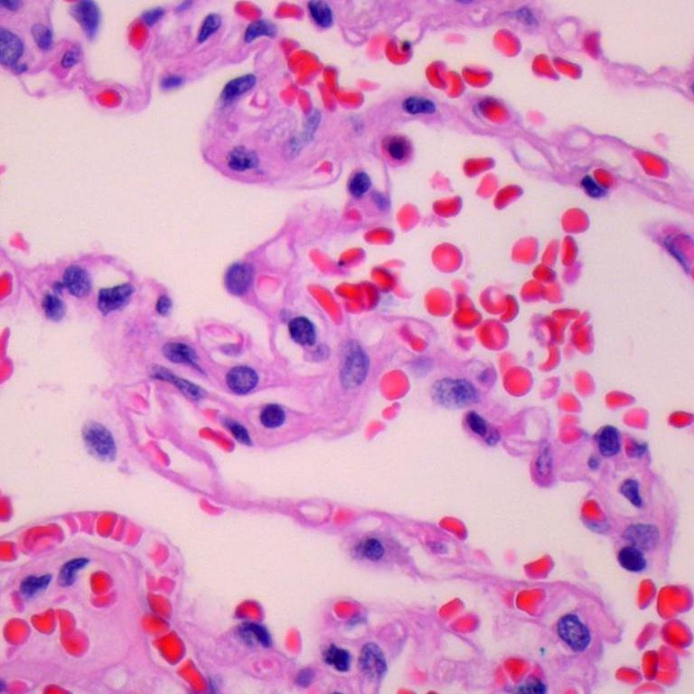

III.Data preparation
For this project the data was pulled out of their original folders and split into three folders: train, test and validation. The split of data is 80% training data, 10% validation data and 10% test data. Within each of these folders for train validation and test there are 3 additional folders to separate the various cancer types. Images are then given the target sizes of (150,150) batch size of 32, the directory for each folder and class being categorical. I utilized google drive to upload images, create various folders and access them in colab. To create the various folders I utilized the split folders import along with os and shutil to create folders and move the various amounts of images into each folder.
IV.Data analysis
To create the model for this project I utilized tensorflow imports including keras models and related image preprocessing tools.The model created for this project is a sequential model that has 9 layers. Some of the layers utilize ReLU activation while the last layer classifies the images into one of the 3 categories and utilizes softmax. The first 6 layers of my model are a mix between Conv2D and MaxPooling2D layers while utilizing ReLU for activation. The 7th layer Flattens and then the last two layers are Dense layers where the first utilizes ReLU again and the last layer utilizes softmax and categorizes the images into 1 of 3 outputs. For optimizer the model utilizes ADAM and for loss function the model utilizes categorical cross entropy. Throughout the 10 epochs the model rapidly increased accuracy with the train data going from 70% accuracy at the start to 95% accuracy by epoch 4. The table below contains the results from the trained model. The overall performance of the trained model is very good with high accuracy and low loss for both train and validation datasets. The Image below represents a similar example of what my model looks like. It takes the image in utilizes ReLU over the course of a few layers, then flattens the layer for classification and then lastly utilizes softmax to classify the image into 1 of 3 categories similar to my case where there are 3 different lung cancers the image can be classified into.
Figure2: Convolutional Neural Network Diagram Example
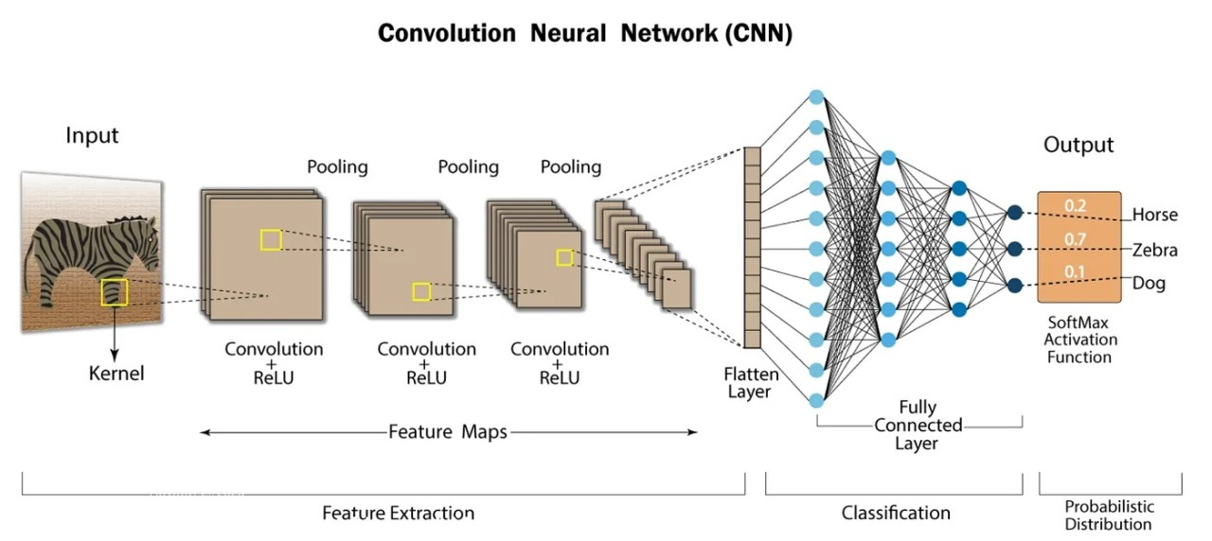
Table 1: Train and validation accuracy and loss values
Train Accuracy | Train Loss | Validation Accuracy | Validation Loss
0.9898 | 0.0280 | 0.9575 | 0.1578

V.Results
After training the model I utilized the model to predict the test data. The image below is the resulting heat map while the table below indicates the metrics produced from predicting the test data.

Figure 3: Heat map of trained model on test data
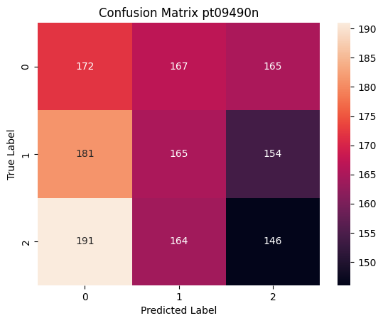
Table 2: Performance metrics of test data
Metric | Value
Accuracy | 0.3209
Precision | 0.3209
Recall | 0.3209
F1-Score | 0.3206

Based on the results presented in the table and heatmap shown above the model did not work well on the test data. This indicates that the model trained is overfit. The labels from the image are as follows 0 is adenocarcinoma, 1 is benign, and 2 is squamous cell carcinoma. Analyzing the confusion matrix it can be seen that with the true label being squamous cell carcinoma it was the least correctly classified out of the 3 different cancers and was mostly labeled as adenocarcinoma. In addition to this we can see for the true label of adenocarcinoma the distribution of predicted labels is very similar across the predicted labels. This could indicate that the 3 different cancers are very similar in appearance making it harder to detect the specific type of cancer presented in the images.

VI.Conclusions:
Regardless of the very good performance from the train and validation data sets the test data had overall poor performance. Comparing the results of the model to my hypothesis, if the model has an accuracy of 70% then the model should be able to accurately predict various forms of lung cancer. This hypothesis was not proven to be true as even though the accuracy of the model was above 90% for both train and validation datasets, the accuracy of the test dataset and overall performance was very low around 32%. One reason this might be the case is that the appearances of the cancers can be very similar to one another making it hard to detect which type it is without noticing a specific aspect of that image.
In future additions to this project, I would refine the model a lot more and have it detect the test data better than what it was. I would experiment with various parameters and numbers of layers and epochs to see how the model would change and try to find the best working model. Also I would see if image augmentation would improve the models performance. In addition, I would also add more types of lung cancers as well as images of lungs without cancer. This would help to catch the other various forms of lung cancers and tumors in addition the model would also be able to recognize normal/healthy lungs. A future adaptation to the dataset to also consider is adding in the various stages of lung cancer from early stages to the later stages showing the growth of the tumors and cancers to help diagnose what stage of cancer the person has. Finally, a change I would make to the model would include adding a cutoff so that if the model’s performance isn’t significantly changing the training would stop.
Looking back at the hypotheses stated earlier, both criterias were met however the results did not match what I was expecting. First the data contained lots of variation within each of the various cancer types. Second, the model had an accuracy of 98.98% for the train and 95.75% for the validation data. While the model performed very well with those datasets the model did not perform with the test dataset.
References
Borkowski AA, Bui MM, Thomas LB, Wilson CP, DeLand LA, Mastorides SM. Lung and Colon Cancer Histopathological Image Dataset (LC25000). arXiv:1912.12142v1 [eess.IV], 2019
Haque, Kh. Nafizul. “What Is Convolutional Neural Network - CNN (Deep Learning).” LinkedIn, 3 Apr. 2023, www.linkedin.com/pulse/what-convolutional-neural-network-cnn-deep-learning-nafiz-shahriar/.

